Circular/harmonic motion | revised 2023-04-14

Angular velocity and angular lenticity (wavenumber)

• Velocity, v = s/Δt, lenticity, u = t/Δs so u = 1/v and v = 1/u except if u or v are zero
- Zero velocity: no motion but time increases because time is independent
- Zero lenticity: no motion but distance increases because distance is independent
- Circular motion in length space and duration space:

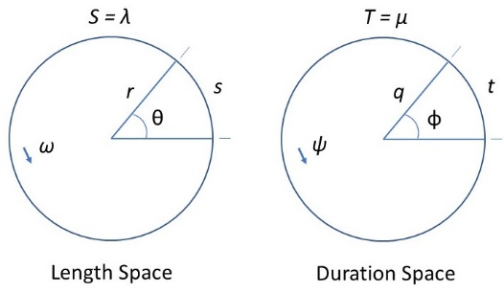

circumference S = 2πr = wavelength λ; period T = 2πq = 1/f = wave duration μ; arc length, s; arc duration, t; radius r; period radius q; time rate of rotation ω; distance rate of rotation ψ; angular wavenumber or repetency k; phase|wave velocity, v_{p} = λ/T = λf = ω/k; phase|wave lenticity, u_{p} = T/λ = k/ω

Circular motion in length space with time (3+1)
- length space angle θ, arc length s, radius r
- length space angle θ ≡ s/r

Time rates of rotation

- Independent variable is time, t; dependent variable is arc length, s
- Angular velocity: time rate of rotation, ω ≡ θ/t
- Wave (phase) velocity: wavelength per unit time, v = s/t = S/T = r/q = ωr
- frequency, f ≡ 1/T = v/S = v/λ = v/s
- wavelength, λ = v/f = S
- angular wavenumber or repetency, k = 2π/λ
- Wave velocity normalized
- revolutions: If S = 1, then v = 1/T = f
- length radians: If r = 1, then s = θ and v = θ/t = ϕ/t = s/t = ω = 2π/T = 2πf
  - ω = 2πf = 2π/T = θ/t

Circular motion in duration space with distance (1+3)
- duration space angle ϕ, arc duration t, period radius q
- duration space angle ϕ ≡ t/q

Distance rates of rotation

- Independent variable is distance, s; dependent variable is (dis)time, t
- Wavenumber (angular lenticity): distance rate of rotation: ψ ≡ ϕ/s
- Wave (phase) lenticity: wave duration per unit distance, u = t/s = T/S = q/r = ψq periodicity, h ≡ 1/S = u/T = u/μ = s/v
- wave duration, μ = u/h = T
- wave duration number, ℓ = 2π/μ
- Wave lenticity normalized
- revolutions: If T = 1, then u = 1/S = h
- duration radians: If q = 1, then t = ϕ = θ and u = ϕ/s = θ/s = t/s = ψ = 2π/S = 2πh
  - ψ = 2πh = 2π/S = θ/s = ϕ/s
Coordinates

length space (r, θ) duration space (q, ϕ)

Wave function for longitudinal wave: cosine wave

length amplitude, A; duration amplitude, B; length phase, θ = ψx; duration phase, ϕ = ωt; distance, s; (dis)time, t; circumference S = wavelength λ; period T = wave duration μ; wave (phase) velocity, v; wave (phase) lenticity, u

length space with scalar time (3+1):

x = A cos(ωt + θ) a = −ω²x in SHM

y(x = 0, t) = A cos(ωt) = A cos(2πft)
y(x, t) = A cos[ω(t – x/v)] = A cos[2πf (x/v − t)] = sinusoidal wave moving in the +x length direction
y(x, t) = A cos[2π (x/λ − t/T)] = A cos(kx – ωt)

∂²y(x, t)/∂x² = (1/v²) ∂²y(x, t)/∂t² length space wave equation

duration space with distance (1+3):

z = B cos(ψs + ϕ) b = −ψ²z in SHM

η(z = 0, s) = B cos(ψs) = B cos(2πhs)
η(z, s) = B cos[ψ(s – z/u)] = B cos[2πh (z/u − s)] = sinusoidal wave moving in the +z duration direction
η(z, s) = B cos[2π (z/μ − s/S)] = B cos(ℓz – ψs)

∂²η(z, s)/∂z² = (1/u²) ∂²η(z, s)/∂s² duration space wave equation

Wave function for transverse wave: sine wave
…

Parametric equations

|r| = r = √(r₁² + r₂²) |q| = q = √(q₁² + q₂²)

r(θ) = r cos(θ) i + r sin(θ) j
r(t) = r cos(ωt) i + r sin(ωt) j; v(t) = ωr; a(t) = −ω²x(t)
r(x) = r cos(x/r) i + r sin(x/r) j

q(ϕ) = q cos(ϕ) i + q sin(ϕ) j
q(s) = q cos(ks) i + q sin(ψs) j; u(s) = ψq; b(s) = −ψ²t(s)
q(z) = q cos(z/q) i + q sin(z/q) j

